Title (Gentium Plus, 20 pt font size, centred)
Subtitle: Gentium Plus, 12 pt font size, centred, not bold

Author name(s): Gentium Plus, 12 pt font size, centred, bold
Author affiliation(s): Gentium Plus, 12 pt font size, centred, not bold

Abstract
The article has to be preceded by an abstract (in English) no more than 250 words in length, set in 12 pt Gentium Plus, in Italics.

Keywords
A list of not more than five keywords, set in 12 pt Gentium Plus, in Italics.

1. Heading level 1: Gentium 16 pt., distance before heading 18 pt.
Main text is Gentium 12 pt., which is available for free download at https://software.sil.org/gentium/. The page is formatted with the following margins: left, top, and right: 2.5 cm; bottom: 2.0 cm. Page numbers are placed at the bottom of each page and are centred. The first paragraph after a section heading is not indented. In this file, templates are defined for all standard elements of an article (page format; title; author name; author affiliation; abstract; three levels of headings; main text; block quotations; bibliography entries; captions). Authors are kindly requested to use these templates as defined in the present file. This would make the work of the editors a lot easier, who, in order to be able to keep the MJR fully open access, are publishing the journal without the support of (and the costs caused by) a commercial publisher.
The second paragraph and every following paragraph of a section is indented. Main text is Gentium 12 pt. Main text is Gentium 12 pt. Main text is Gentium 12 pt. Main text is Gentium 12 pt. Main text is Gentium 12 pt. Main text is Gentium 12 pt. Main text is Gentium 12 pt. Main text is Gentium 12 pt. Main text is Gentium 12 pt. Main text is Gentium 12 pt. Main text is Gentium 12 pt. Main text is Gentium 12 pt. Main text is Gentium 12 pt. Main text is Gentium 12 pt. Main text is Gentium 12 pt. Main text is Gentium 12 pt.
“Quotations more than two lines in length are presented as block quotations in double inverted commas, Gentium 12 pt, indented on both sides by 1.0 cm and both preceded and followed by a 10 pt space.”
Main text is Gentium 12 pt. Main text is Gentium 12 pt. Main text is Gentium 12 pt. Main text is Gentium 12 pt. Main text is Gentium 12 pt. Main text is Gentium 12 pt. Main text is Gentium 12 pt. Main text is Gentium 12 pt. Main text is Gentium 12 pt. Main text is Gentium 12 pt. Main text is Gentium 12 pt. Main text is Gentium 12 pt. Main text is Gentium 12 pt. Main text is Gentium 12 pt. Main text is Gentium 12 pt. Main text is Gentium 12 pt.

1. Heading level 1: Gentium 16 pt., distance before heading 18 pt.
Main text is Gentium 12 pt. Main text is Gentium 12 pt. Main text is Gentium 12 pt. Main text is Gentium 12 pt. Main text is Gentium 12 pt. Main text is Gentium 12 pt. Main text is Gentium 12 pt. Main text is Gentium 12 pt. Main text is Gentium 12 pt. Main text is Gentium 12 pt. Main text is Gentium 12 pt. Main text is Gentium 12 pt.

1.1. Heading level 2: Gentium 14 pt., distance before heading 12 pt.
Main text is Gentium 12 pt. Main text is Gentium 12 pt. Main text is Gentium 12 pt. Main text is Gentium 12 pt. Main text is Gentium 12 pt. Main text is Gentium 12 pt. Main text is Gentium 12 pt. Main text is Gentium 12 pt. Main text is Gentium 12 pt. Main text is Gentium 12 pt. Main text is Gentium 12 pt.

1.1.1. Heading level 3: Gentium 12 pt., distance before heading 12 pt.
Main text is Gentium 12 pt. Main text is Gentium 12 pt. Main text is Gentium 12 pt. Main text is Gentium 12 pt. Main text is Gentium 12 pt. Main text is Gentium 12 pt. Main text is Gentium 12 pt. Main text is Gentium 12 pt. Main text is Gentium 12 pt. Main text is Gentium 12 pt. Main text is Gentium 12 pt. Main text is Gentium 12 pt. Main text is Gentium 12 pt. Main text is Gentium 12 pt. Main text is Gentium 12 pt. Main text is Gentium 12 pt.

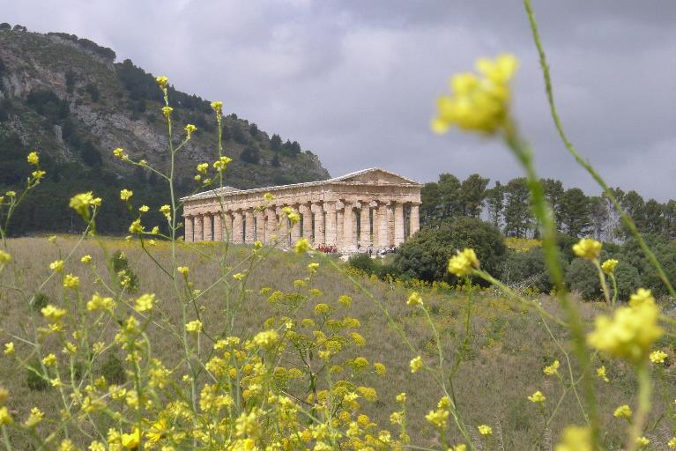
Illustrations should be embedded in the text file at the correct place as well as sent as separate high-resolution image files (.TIFF or .JPG). A caption that includes a copyright notice is placed directly below every illustration. Authors have to ensure that they have permission to use any illustrations they want to include and are solely liable to cover any costs arising from them. The copyright notice is placed at the end of the caption following the format: © Copyright holder. Used with permission.
Main text is Gentium 12 pt. Main text is Gentium 12 pt. Main text is Gentium 12 pt. Main text is Gentium 12 pt. Main text is Gentium 12 pt. Main text is Gentium 12 pt. Main text is Gentium 12 pt. Main text is Gentium 12 pt. Main text is Gentium 12 pt. Main text is Gentium 12 pt. Main text is Gentium 12 pt. Main text is Gentium 12 pt. Main text is Gentium 12 pt. Main text is Gentium 12 pt. Main text is Gentium 12 pt. Main text is Gentium 12 pt. Main text is Gentium 12 pt. Main text is Gentium 12 pt. Main text is Gentium 12 pt. Main text is Gentium 12 pt. Main text is Gentium 12 pt. Main text is Gentium 12 pt. Main text is Gentium 12 pt. Main text is Gentium 12 pt. Main text is Gentium 12 pt. Main text is Gentium 12 pt. Main text is Gentium 12 pt. Main text is Gentium 12 pt. Main text is Gentium 12 pt. Main text is Gentium 12 pt. Main text is Gentium 12 pt. Main text is Gentium 12 pt. Main text is Gentium 12 pt.

Acknowledgements (heading level 1)
Acknowledgements are formatted like main text. Main text is Gentium 12 pt. Main text is Gentium 12 pt. Main text is Gentium 12 pt. Main text is Gentium 12 pt. Main text is Gentium 12 pt.

Bibliography (heading level 1)

Published sources (heading level 2)
Entries in the bibliography are formatted according to the rules for lists of cited literature as defined by the Chicago Manual of Style for its author-date-system. They are typeset in Gentium 11 pt., left aligned. Entries exceeding one line in length are indented by 0,7 cm from the second line onwards.
Entries in the bibliography are formatted according to the rules for lists of cited literature as defined by the Chicago Manual of Style for its author-date-system. They are typeset in Gentium 11 pt., left aligned. Entries exceeding one line in length are indented by 0,7 cm from the second line onwards.

Archival sources (heading level 2)
Entries in the bibliography are formatted according to the rules for lists of cited literature as defined by the Chicago Manual of Style for its author-date-system. They are typeset in Gentium 11 pt., left aligned. Entries exceeding one line in length are indented by 0,7 cm from the second line onwards.
Entries in the bibliography are formatted according to the rules for lists of cited literature as defined by the Chicago Manual of Style for its author-date-system. They are typeset in Gentium 11 pt., left aligned. Entries exceeding one line in length are indented by 0,7 cm from the second line onwards.

Footnotes are left-aligned, Gentium 10 pt.

