Visual Material Appendix

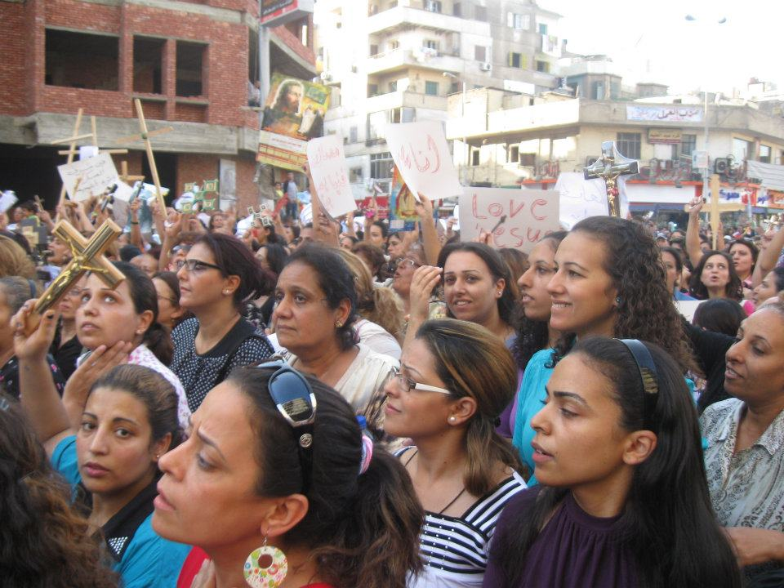
Figure 1
Photo by author: Maspero Protest October 9, 2011

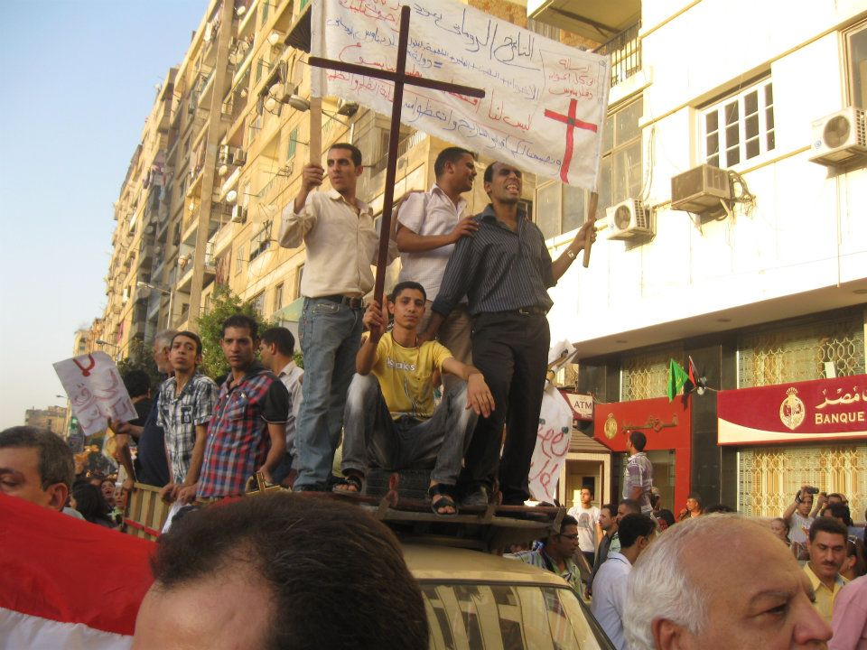
Figure 2
Photo by author: Maspero Protest October 9, 2011

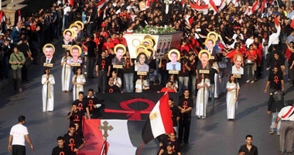
Figure 3: Source: Al- Youm al- Sabi’, awaiting copyright permission

Figure 4: Egyptian flag: Wikicommons

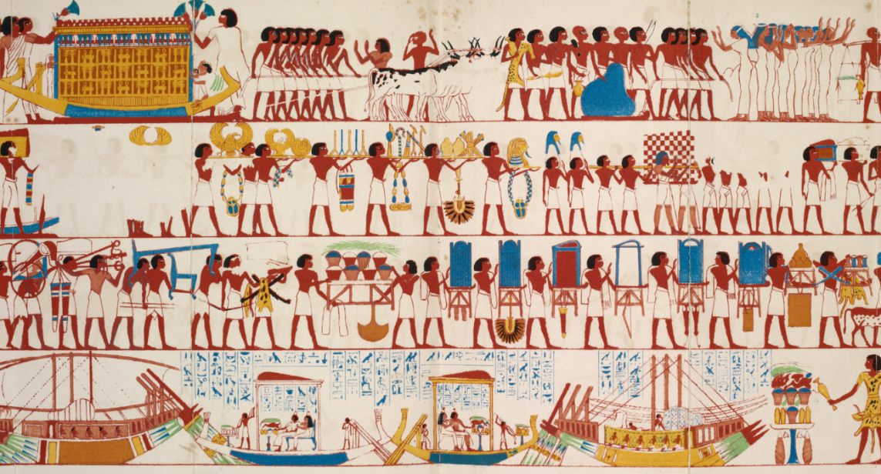
Figure 5
Theban Funeral Ceremony
Source New York Public Library (Public Domain)

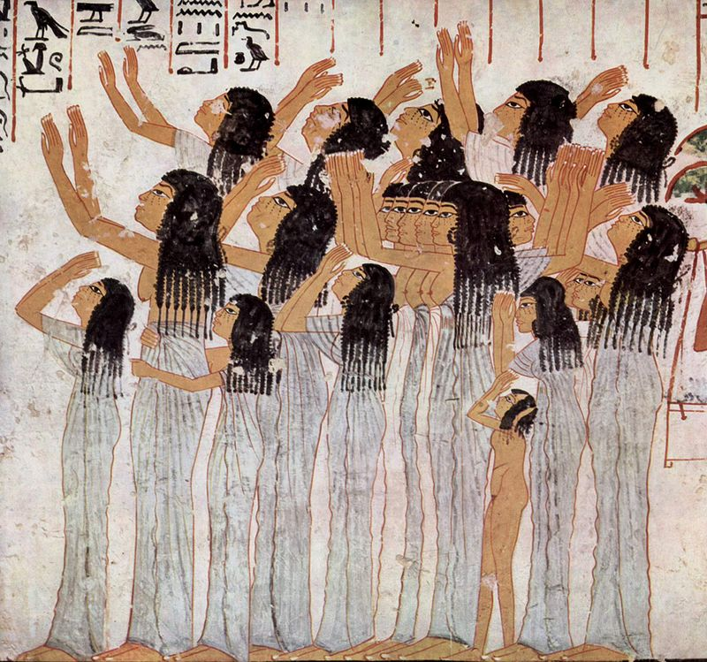
Figure 6: Wailing Women in Ancient Egypt Funeral. Source Wikimedia common (Public Domain)

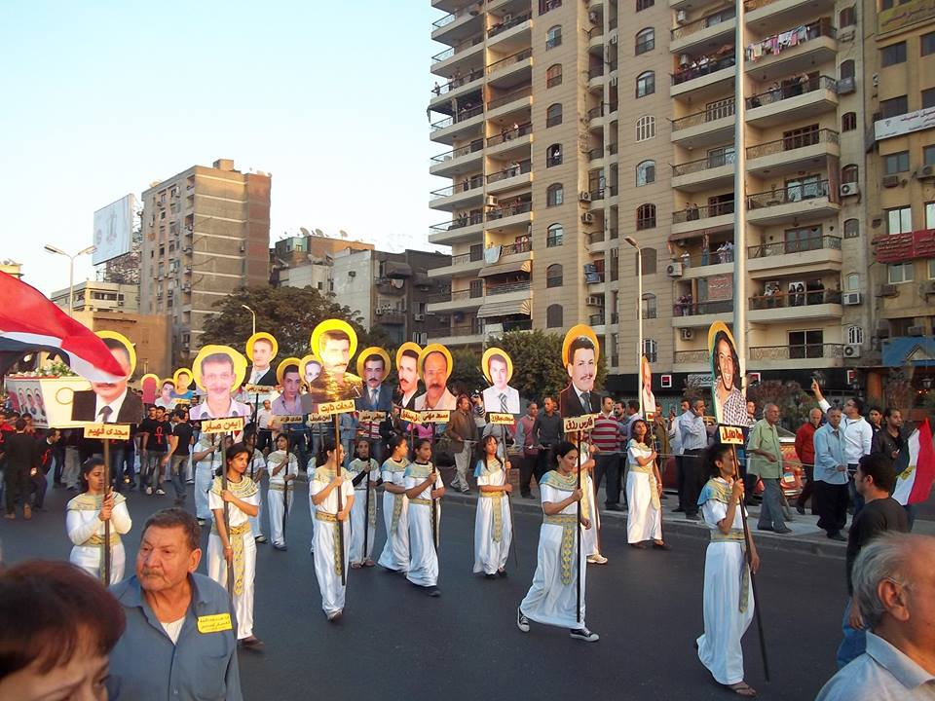
Figure 7. First Commemoration: Photo by Mina Thabet used with permission

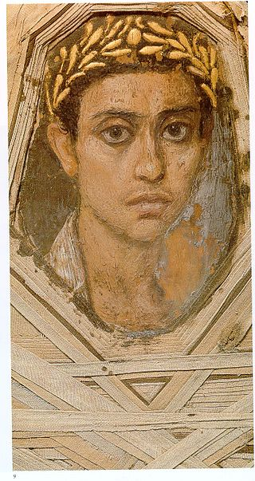
Figure 8: A Fayyum Portrait of a man
Source Wikimedia common (Public Domain)

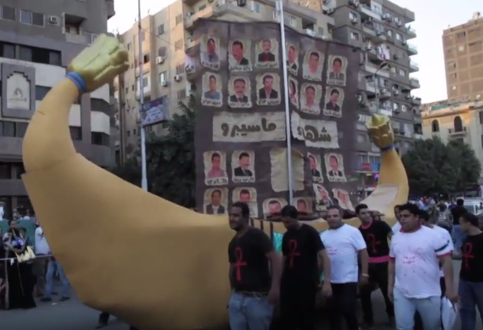
Figure 9: Second Commemoration Ceremony Solar Boat
Mosireen Collective Video https://www.youtube.com/watch?v=upSBsfT5oLc (creative commons for downloading, remixing and screening for non-commercial use)

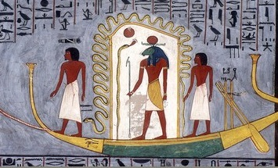
Figure 10: Sun God traveling in Barque
Source: Wikimedia commons

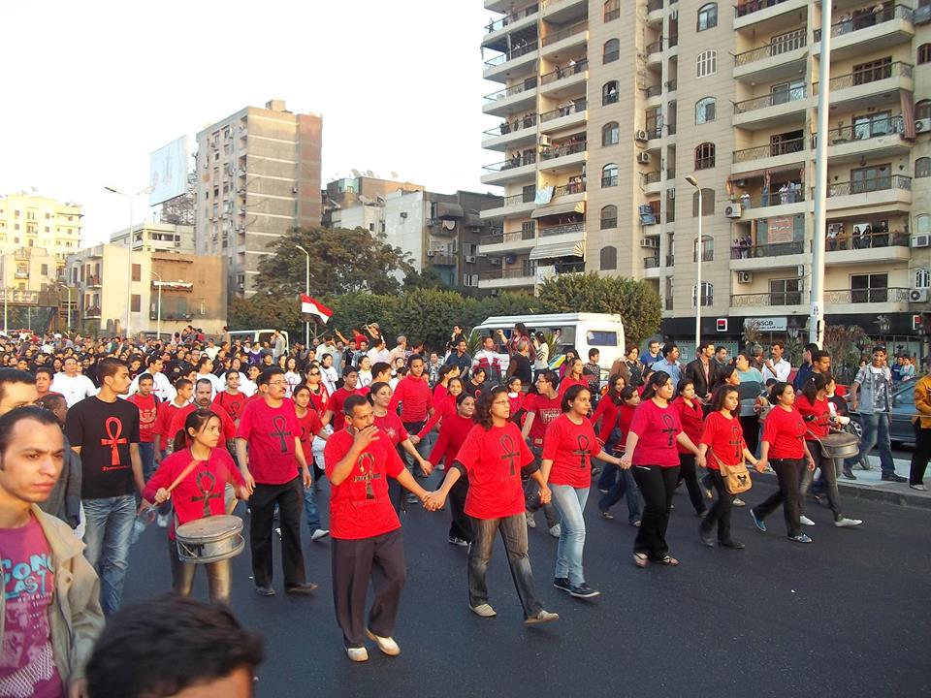
Figure 11:First Commemoration: Photo by Mina Thabet, used with permission

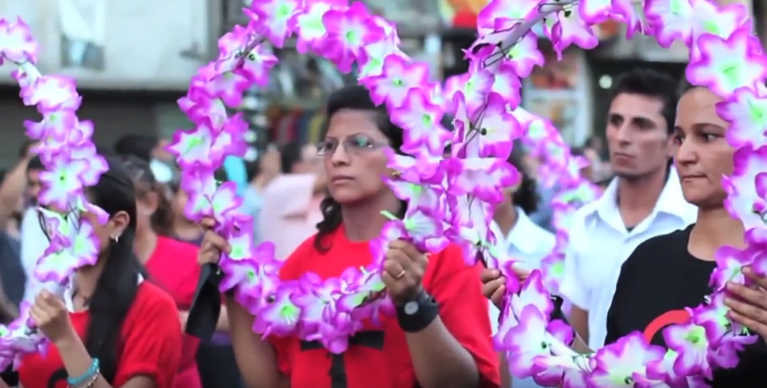
Figure 12: Second Commemoration Ceremony wreaths of flowers
Mosireen Collective Video https://www.youtube.com/watch?v=upSBsfT5oLc (creative commons for downloading, remixing and screening for non-commercial use)

Videos Used for Analysis:
First Ceremony
Al- Katiba Al- Tibiya, “Ihtifaliyit Ta’bin Shuhada Maspiro Kamila” YouTube. Web. November 13, 2011. https://www.youtube.com/watch?v=Fou6tRN6ZfA September 29, 2016
Bora S. Kamel (2011). “al- march al- gana’izi: Masirat ta’bin shuhada maspiro” YouTube. Web. November 11, 2011 https://www.youtube.com/watch?v=Bhdwiz3hNB0 September 29, 2016
Bora S. Kamel (2011). “bid’ al- taharuk : Masirat ta’bin shuhada maspiro” YouTube. Web. November 11, 2011 https://www.youtube.com/watch?v=e9F4JdEi2vY September 29, 2016
Second Ceremony:
The Mosireen Collective , “Anniversary of the Maspero Massacre”. YouTube . Web. October 11, 2012. https://www.youtube.com/watch?v=upSBsfT5oLc September 29, 2016
Al- Katiba Al- Tibiya, “Masirat al- Zikra al- Ula lshuhada Maspiro” YouTube. Web. October 11, 2011. https://www.youtube.com/watch?v=cE1NNjpaWEc September 29, 2016

